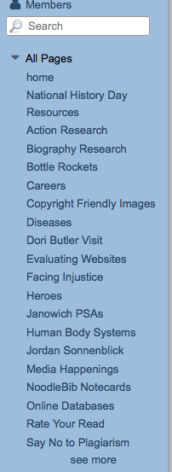
Gale Database Directions
- Go to GMS Home
- Click on the Media Center link on the left
- Click on the Online Database on the right side

- Find the Database Gale Student Resource Center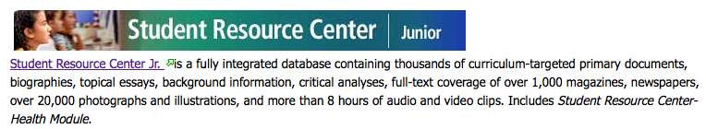
- Click on Proceed.
- Under Basic Search, enter your topic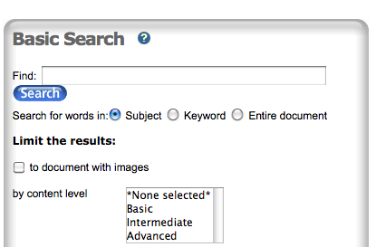
- Check your list of sources before you select on.
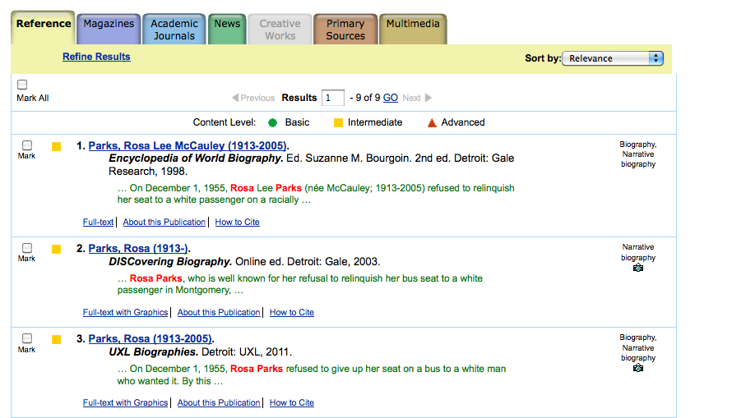
  - Notice the tabs at the top- Do you want a
    - Reference- general overviews
    - Magazine- current monthly or weekly articles
    - Academic Journals- very scholarly analysis
    - News- Current daily updates on topic
    - Primary Sources- you know this one- speeches, letters, etc
    - Multimedia- pictures or videos
    - Creative works- fictional text based on your topic
  - Color shape
    - Green circle- basic
    - Yellow square- average difficulty
    - Red triangle- advanced
  - Publication date- newer is better
- Select a resource to explore
- Read or listen through once to make sure this source has new information for you.
- If this selection is too difficult to understand or doesn’t provide any new information, go back to the original list and select a new source.
- If you want to capture notes from this selection, write down the Bibliographic information on a Blue Cornel Notes
- Take notes
- If time runs out, document where you stopped so you can continue tomorrow.

